Project Proposal:
Interpretable Multimodal Spatio-Temporal Graph Transformer for Alzheimer's Disease Prediction Through SNP–Brain Imaging Integration
- Our spatio temporal graph transformer is the main learning and integration engine of our proposed model, its role is to learn how different brain regions interact, how those iteraction change over time and how genetic and structural information relate to those patterns.
- Modalities I will be using:
  - SNPs: genetic variations that may be associated with AD susceptibility
  - sMRI: structural measurements of the brain such as hippocampal volume and cortical thickness
  - fMRI: functional brain activity showing how activity and connectivity between brain regions change over time
- So the transformer processes representations from all these modalities and learn relationships between them
- For the multi-modal fusion I will be using Bipartite graph: representing SNP-ROI (associations between genetic variants and brain regions)
- We gonna have two types of learning:
  - Spatial learning where the model learns relationships between different braini regions and potentially their associations with genetic information
  - Temporal Learning where the model processes successive fMRI time windows and learns how functional connectivity patterns evolve
- I am going to use Transformer because the core mechanism of this latter is attention mechanism that learn which relationships are important for its prediction (cross modal attention)
- The final output will be an integrated representation that can be used for an Alzheimer related prediction task (a novelty would be which participants with MCI will progress to Alzheimer disease + Healthy control vs MCI vs Alzheimer's disease.)
- The Spatio-Temporal Graph Transformer learns relationships across these sources to produce a joint representation for Alzheimer's prediction.
- 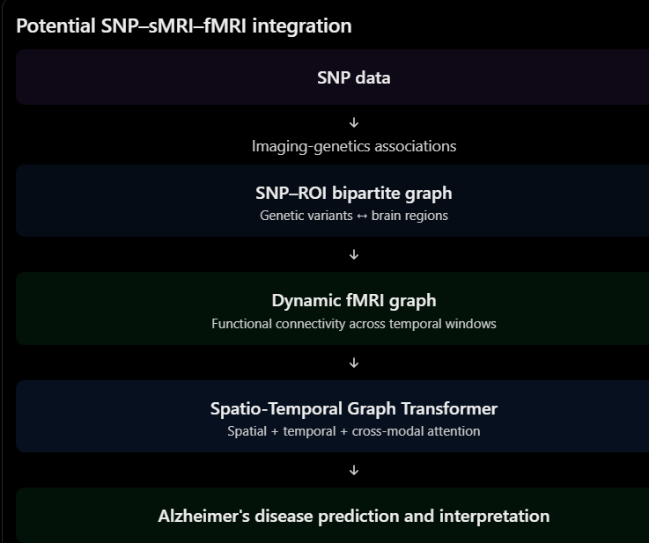
- For the three graphs how they connect both of them share regions of interests
- 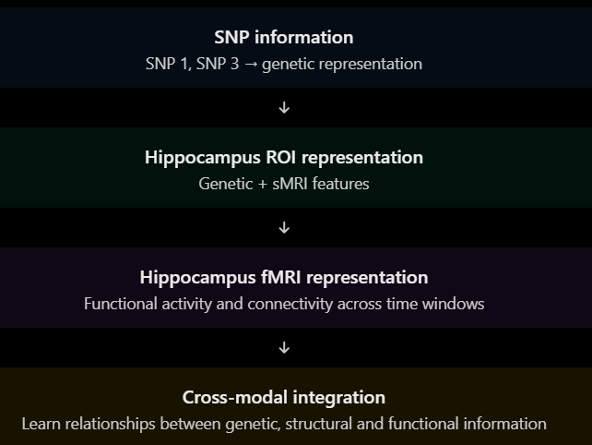
- The fMRI and SNP can connect to each other indirectly through a shared ROI
- should the genetic and structural information be incorporated into each ROI's node representation before temporal fMRI processing, or should all three representations be fused after their separate encoders(they should be compared experimentally)



